Friend in High Places

**A.**

Our project is a visualization of the Twitter and corresponding location data from an astronaut, Samantha Cristoforetti, in the International Space Station (ISS). We primarily used two datasets. The first dataset we have used is world-50.json which was used to plot the world map. One dataset is orbiting data of ISS from the “International Space Apps Challenge”. The dataset provides us very detailed information about the location of the ISS. Variables we used from this dataset are:

* “orbitId” (unique identification number for each orbit),
* within the “orbit” object, there are three variables,
  + “coordinates” (coordinates of each point of the orbit, including longitude and latitude data),
  + “timestamps" (timestamp in UTC format of each orbit point), and
  + “altitudes” which we did not use.

The last dataset we get is from Samantha’s Twitter account. We download this data using Twitter API into one Json file. There are several variables used in this Json file, including

* “id” (unique identification number for each Tweet),
* “timestamp” (timestamp in UTC format of each Twitter post),
* “html” (the text of the whole post, including HTML tags for each links)
* “coordinates” (longitude and latitude data for where each tweet was sent.

**B.**

According to the relevant data, we plot a trace a trace of the ISS’s path on the map as a series of points. Users can choose to either show a trace of the station’s path for the day or a single a trace of a single orbit. The timestamp variable is used to map each trace point to an array according to that timestamp, which allows users to select a specific date and time and see where the ISS was at that time. Twitter data is presented in a sidebar as users progress along the timeline. These tweets are ones that were made within a frame of time relatively close the currently selected date and time. Users will be able to progress through the timeline by hand or by pressing the “Play” button, which will progress automatically at a speed they can control. Our map is using Kavrayskiy VII projection, which gives us a more accurate world map projection in 2D comparing to Equirectangular and Mercator projections.

**C.**

In more than three month of her time in the space, Samantha posted more than 2000 tweets from the space, which includes more than three hundred different hashtags. Following her journey in the space, we can see where she is, where she posted her tweets in the space, and what is in that twitter post. It is surprising that for someone on a mission, in the space post tweets many times a day.

Moreover, it is surprising to us that the ISS orbits earth is a very regularly, and it forms a very regular band around earth if you look at the daily trace points. Below, we attached a graph which we plotted all the ISS orbiting coordinate points, about 300,000 data points. Surprisingly, it form a very nice band around earth, and it never goes beyond certain latitudes. It is amazingly nice formed, and it seems this orbiting trace graph has a center in it. This graph along with the interactive map we have demonstrated why Samantha only have photos and tweets about certain regions on earth, but not everywhere.

All points plotted:

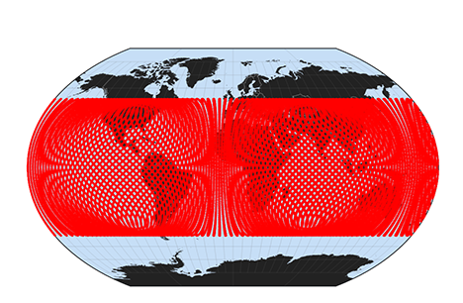

Screenshot of our interface:

